**WEEK 5 :** **CI/CD Pipeline with Azure DevOps**

**Pre-requisites:**

* Ensure **SSH Public Key** or **Personal Access Token (PAT)** for HTTPS is already configured.
* Install **Git**, **Python**, and **VS Code / any IDE**.
* Have your project folder ready on your local system, which includes:
  + Python file for **expense alert**
  + Azure pipeline YAML file

**Step 1: Create Python and YAML Files in Local Project**

1. Create a Python file (e.g. alert.py)  
   Example:

# alert.py

def check_expense(monthly_total, limit):

if monthly_total > limit:

print(f"Alert! Monthly expense ₹{monthly_total} exceeds the limit of ₹{limit}")

else:

print("Expense within limit.")

1. Create a YAML file for Azure Pipeline (e.g. azure-pipelines.yml)  
   Example:

trigger:

- main

pool:

vmImage: 'ubuntu-latest'

steps:

- task: UsePythonVersion@0

inputs:

versionSpec: '3.x'

- script: |

python Personal_Expense_Monitoring_System/

displayName: 'Successfully Run'

- script: |

python alert_expense.py

displayName: 'Expense Alert'

**Step 2: Create a New Azure DevOps Project**

1. Go to [Azure DevOps Portal](https://dev.azure.com).
2. Click **New Project** → Provide name and visibility → Click **Create**.
3. Navigate to **Repos** → Click **Clone** → Copy the **SSH** URL.

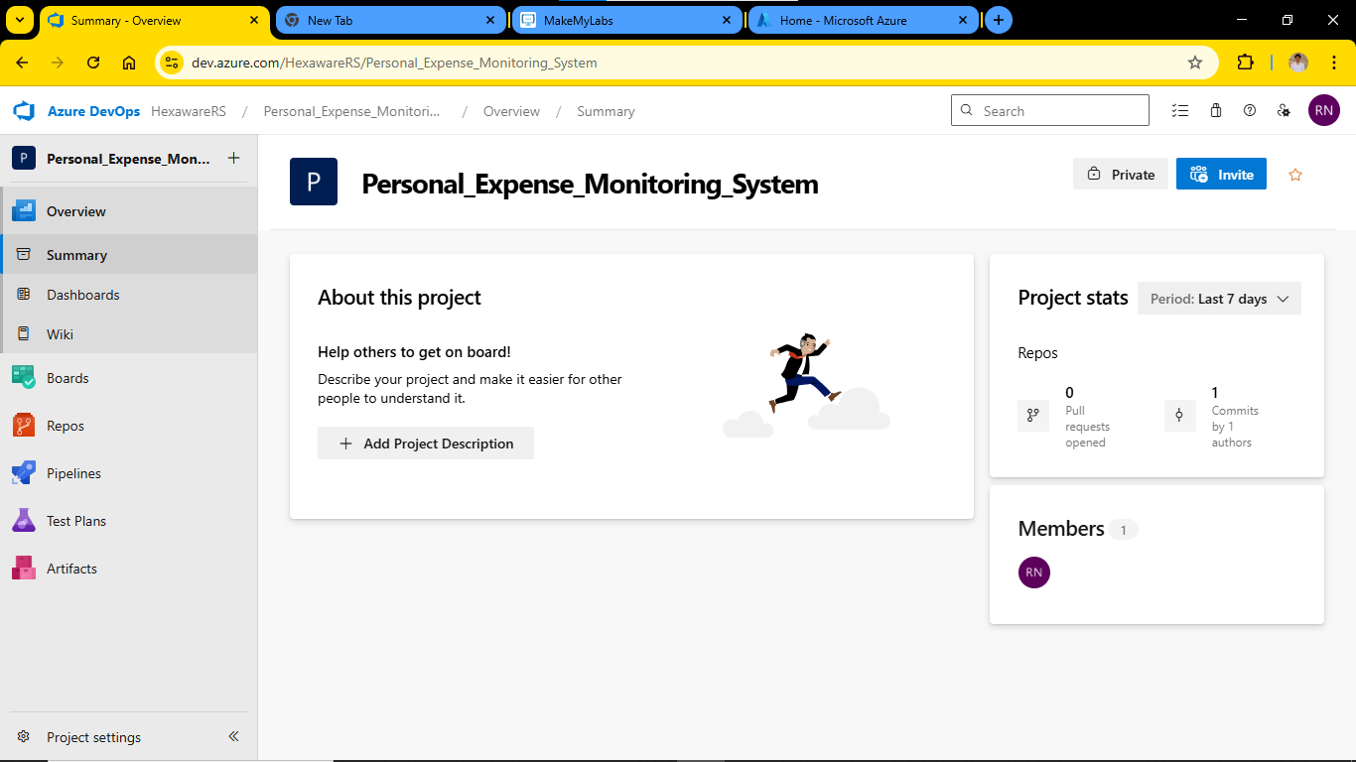

**Step 3: Push Local Project to Azure Repo via SSH**

Open **Command Prompt / Git Bash**, then run the following:

# Go to the directory where your local project exists

cd path\to\your\project-folder

# Initialize git repository

git init

# Add files to git

git add .

# Commit the files

git commit -m "Initial commit"

# Add Azure DevOps repo as remote (replace with your SSH link)

git remote add origin git@ssh.dev.azure.com:v3/YourOrg/YourProject/YourRepo

# Push the code to Azure repo

git push -u origin main

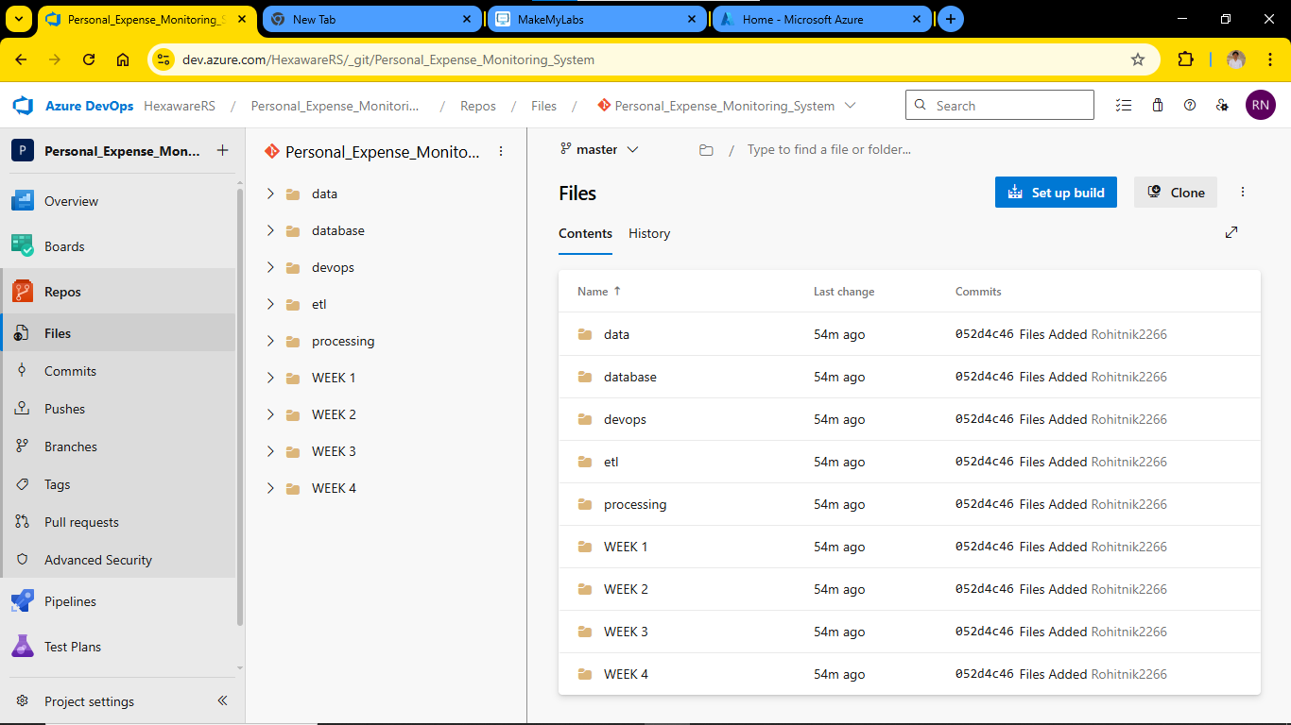

**Step 4: Configure and Run the Azure Pipeline**

1. Go back to your Azure DevOps project.
2. Navigate to **Pipelines** → Click **Create Pipeline**.
3. Choose:
   * **Code in Azure Repos Git**
   * Select your repository
   * Choose **"Existing Azure Pipelines YAML file"**
4. Select:
   * **Branch:** main
   * **Path:** /devops/azure-pipelines.yml
5. Click **Continue**, then **Run** the pipeline.

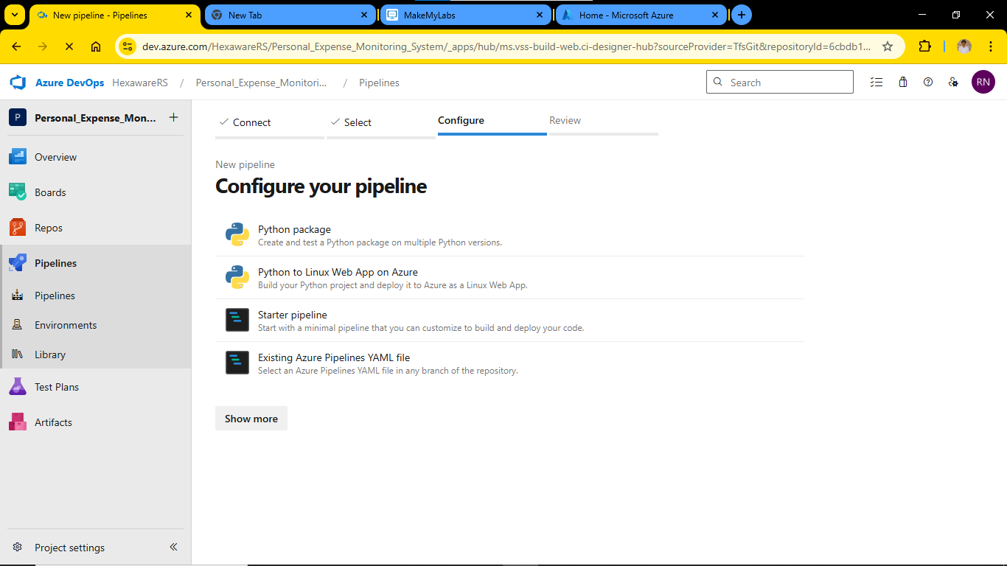

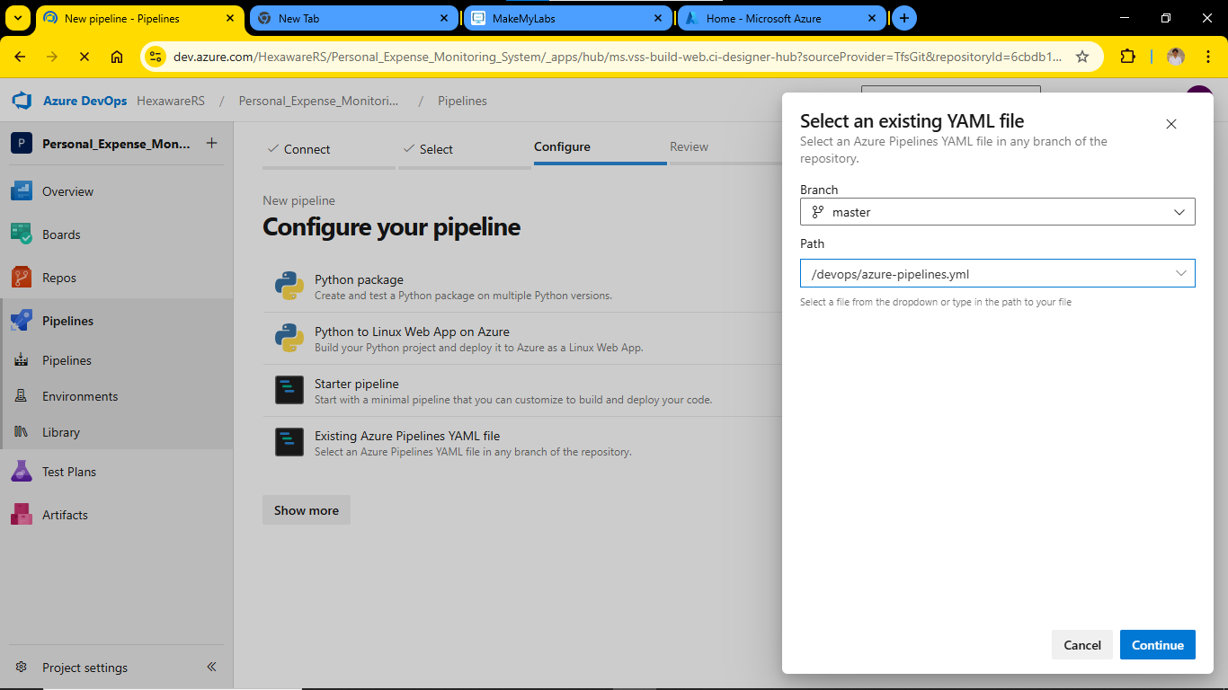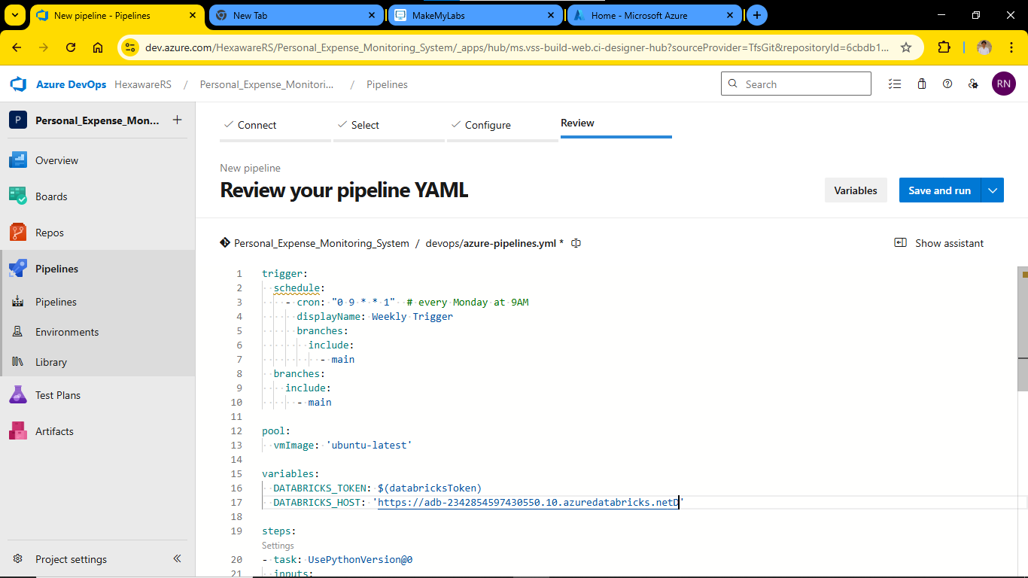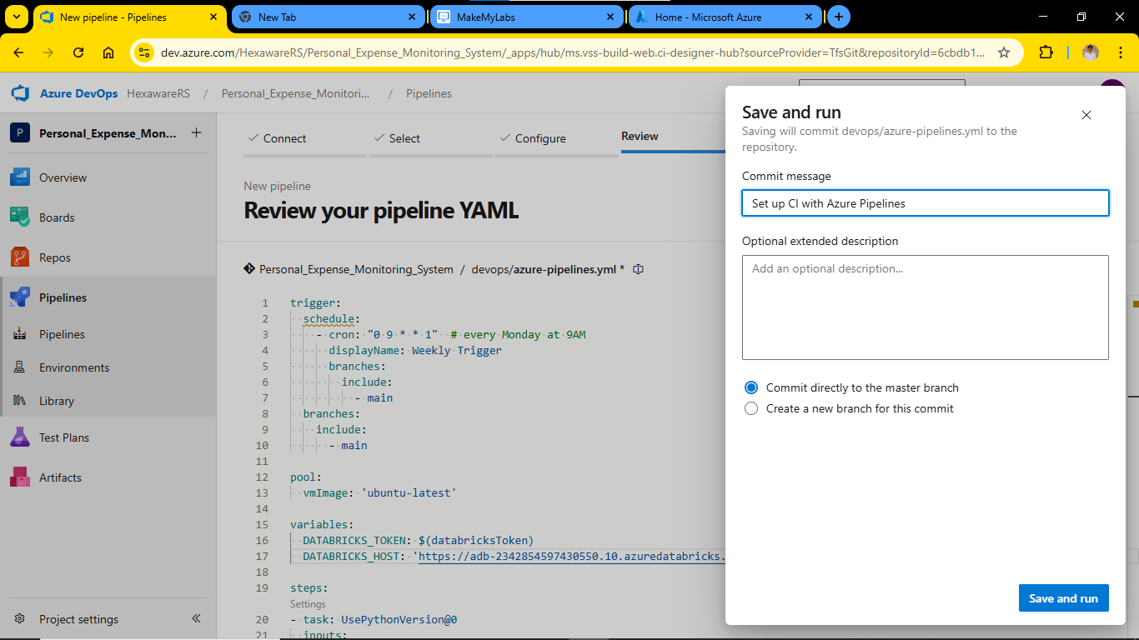

**✅ Final Output**

* The pipeline will run automatically.
* It will set up the environment, run your all file and alert.py, and display output in logs.
* If everything is set correctly, you'll see **“Successfully Run” and “Expense Alert”** message.

